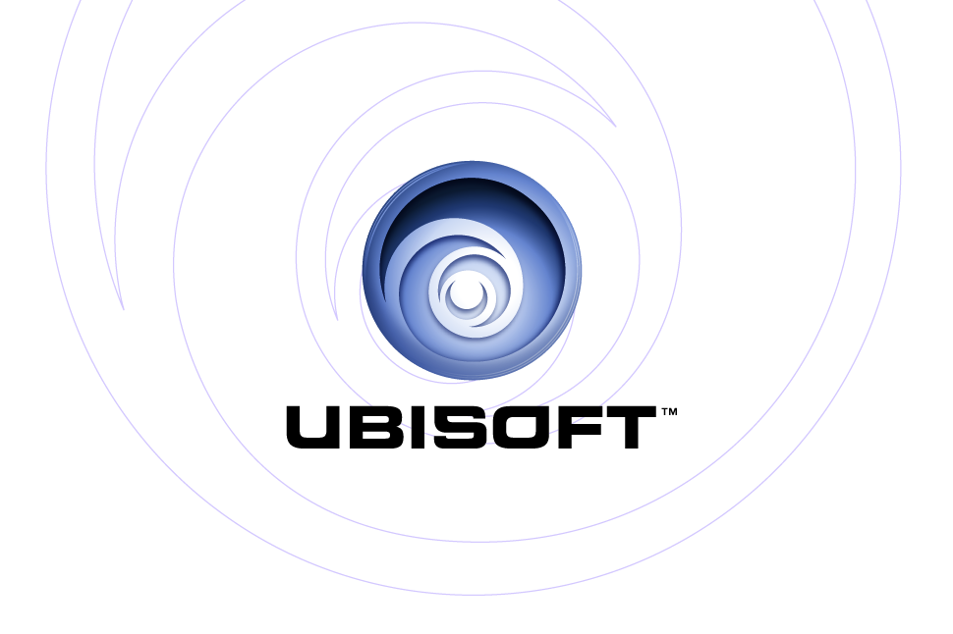
PRESENTS: | Xbox®
Chessmaster®

Product Description

Chessmaster®, the best-selling chess brand of all time, brings history’s greatest game to the Xbox. Challenge a variety of AI-controlled opponents or test your skills online. Chessmaster is Xbox Live™ enabled, allowing players to challenge other online players, receive a ranking, chat with friends and join a thriving online chess community. Whether you are new to chess or a tournament-level player, Chessmaster can improve your game at every level. It’s powerful enough to challenge a Grandmaster but wise enough to teach an absolute beginner.

Key Features

- Play chess live online.
Square off against other players live and meet friends to chat about chess. Play for fun or challenge other ranked players and receive a chess ranking. For the first time, players can play chess online on Xbox Live.

- Learn new ways to win with extensive coaching features.
Experience an extensive training mode that will improve your game with features such as quick hints, extensive advice, game analyses and blunder alert warnings. Challenge a huge variety of computer- controlled opponents and allow the chess-coaching features to face stronger opponents as your skills improve.

- Receive personalized instruction at Chessmaster Academy.
Receive extensive advice from International Master Josh Waitzkin, whose childhood as a chess prodigy was portrayed in the movie Searching for Bobby Fischer™. Strategies for attacking chess are covered by teacher and Grandmaster Larry Christiansen. The Chessmaster himself can also instruct players on the basics of the game.

- More fun for the whole family.
Features such as special chess sets that animate as they move, a variety of brain-teasing chess puzzles, and a simplified learning section make chess more fun than ever. Younger players will appreciate viewing the sets in ultra 3D using the special glasses enclosed in the box. As players improve, they can face the appropriate AI-controlled opponents and progress at their own pace.

- Intermediate and advanced player options.
Seasoned chess players can test their skills against over 180 ranked AI opponents or participate in over 60 predefined tournaments or customize their own tournament. They can also sharpen their expert drills in the end-game quiz.
Product Specifications:
Publisher: Ubisoft
Developer: Ubisoft Bucharest Studio
Ship Date: October 26, 2004
Category: Board game/Strategy Game
Rating: E (mild fantasy violence)

